For the entire lab, please use Aseptic technique. Flame your loops or use new disposable loops. Make sure your plates are labelled properly!

- - Look at your RT and Cold plates from last week.
- Make observations.
- Count CFUs if possible.
- Calculate the original microbial load.

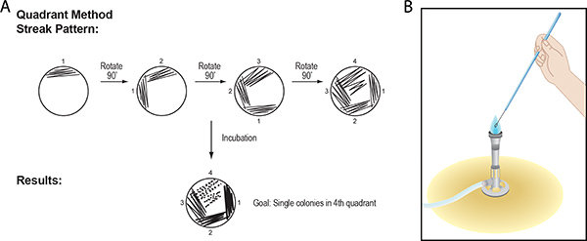
- Every student: Select a colony from any of your group plates. Both partners in the group can pick a colony from the same plate if you wish. If you want, you can even pick a colony from another group’s plate. Aim to pick “different looking” colonies.

- Touch or pick up the colony with your loop. The aim is to isolate a pure culture of that colony; therefore, it is better to pick up/touch “less” of your chosen colony and not risk touching other surrounding colonies.

- Preform the streak plate techniques with the colony.

- Incubate the new streaked plate at the same temperature as the plate where the colony was isolated from.

- Test if this colony also grows at the other temperature. For example, if you isolated your colony from an RT plate, now test if it will grow in the fridge.

To do this:

- Working with 4 people total, separate one plate into 4 quadrants. Each quadrant will be inoculated with a different colony.
- Use a new sterile loop or a reusable flame sterilised loop. Use the loop to pick up some of your chosen colony from Step 4 by streaking the loop through the most concentrated part of the streak plate. The most concentrated part is Area 1 in the graphic below.
- Streak one of the quadrants of the new plate. Pass on the plate to another person.
- Store the plate at the opposite temperature than the isolated colonies.
